Carlisle High School Marching Band
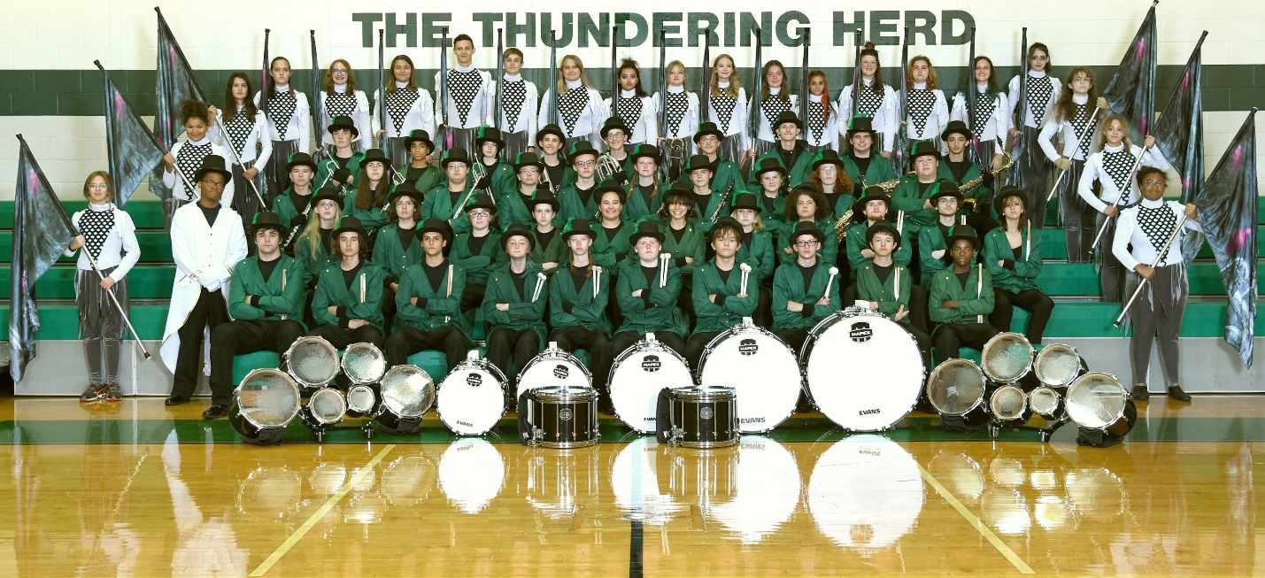
The Carlisle High School Band is proud to present their 2022 field show, Haunted Symphony.
Early in the show, a musical motif is developed at the piano and throughout the show, this idea recurs – eventually becoming entwined in the final symphony with all the musicians on the field.
Soloists for Haunted Symphony include Kai Lesman on baritone and Matthew Franzen on clarinet. Danielle Rubendall and Renae Greak are guard and dance soloists.
The band is led on the field by drum major, Dez Morris.
The band is under the direction of Byron Mikesell assisted by Abel Rose. Haunted Symphony show design is by Dustin Smith. Battery and percussion staff serving the band are: Charity Kennedy Bixler, Bryce Doane, Spencer Pakiwa, Tim Rarick, Bryce Fisher, Ryan Cleary and Paul McIlhenny.
Guard and visual staff are Kelly Smith, Emily Moglia, Kayla Hechler, Xavier Muza, Amir Pulley, Charity Kennedy Bixler, Ben Adelberg, and Liz McCreary. Instructional staff for woodwinds and brass include Adam Marrazzo and Caitlyn Gilmore.

The band would like to thank all the parent volunteers who have assisted with the many things necessary for getting everybody and everything on the field tonight – from uniform fittings to designing, building and painting props, chaperoning, and other responsibilities.
Ladies and Gentlemen, please enjoy tonight’s performance of Haunted Symphony!
